**Netflix Report**

**Introduction**

The Netflix login page serves as the gateway to a world of entertainment, offering users access to an extensive library of movies, TV shows, and original content. It's an essential entry point for millions of subscribers, designed to provide a seamless and captivating experience.

Upon landing on the Netflix login page, users are met with a sleek and modern design that reflects the platform's commitment to high-quality visual presentation. The page sets the tone for the rich cinematic experience that awaits users once they log in.

**Purpose of the report**

This report aims to provide a comprehensive analysis of the Netflix login page, delving into the HTML and CSS elements used, responsive design considerations, user experience, and accessibility. It seeks to highlight the strengths and potential areas for improvement of the login page, offering valuable insights for optimizing the user login journey.

By thoroughly examining the login page's structure, design, and functionality, this report aims to equip stakeholders with actionable recommendations to enhance user engagement and streamline the login process for a seamless user experience.

**Overview of Netflix login page**

**User-Friendly Interface**

The Netflix login page features a user-friendly interface, with clear navigation and intuitive elements to guide users through the login process seamlessly.

**Engaging Visuals**

Visually captivating imagery and strategic use of color schemes create an immersive experience, setting the stage for what users can expect from the streaming platform.

**Concise Information**

Relevant and succinct information is presented on the login page, providing users with quick access to account-related details and updates.

**HTML structure and elements used**

The HTML structure of the Netflix login page is meticulously crafted to ensure optimal usability and seamless integration with CSS for sleek presentation. Key HTML elements, such as forms, input fields, and buttons, are strategically organized to facilitate a streamlined user login process.

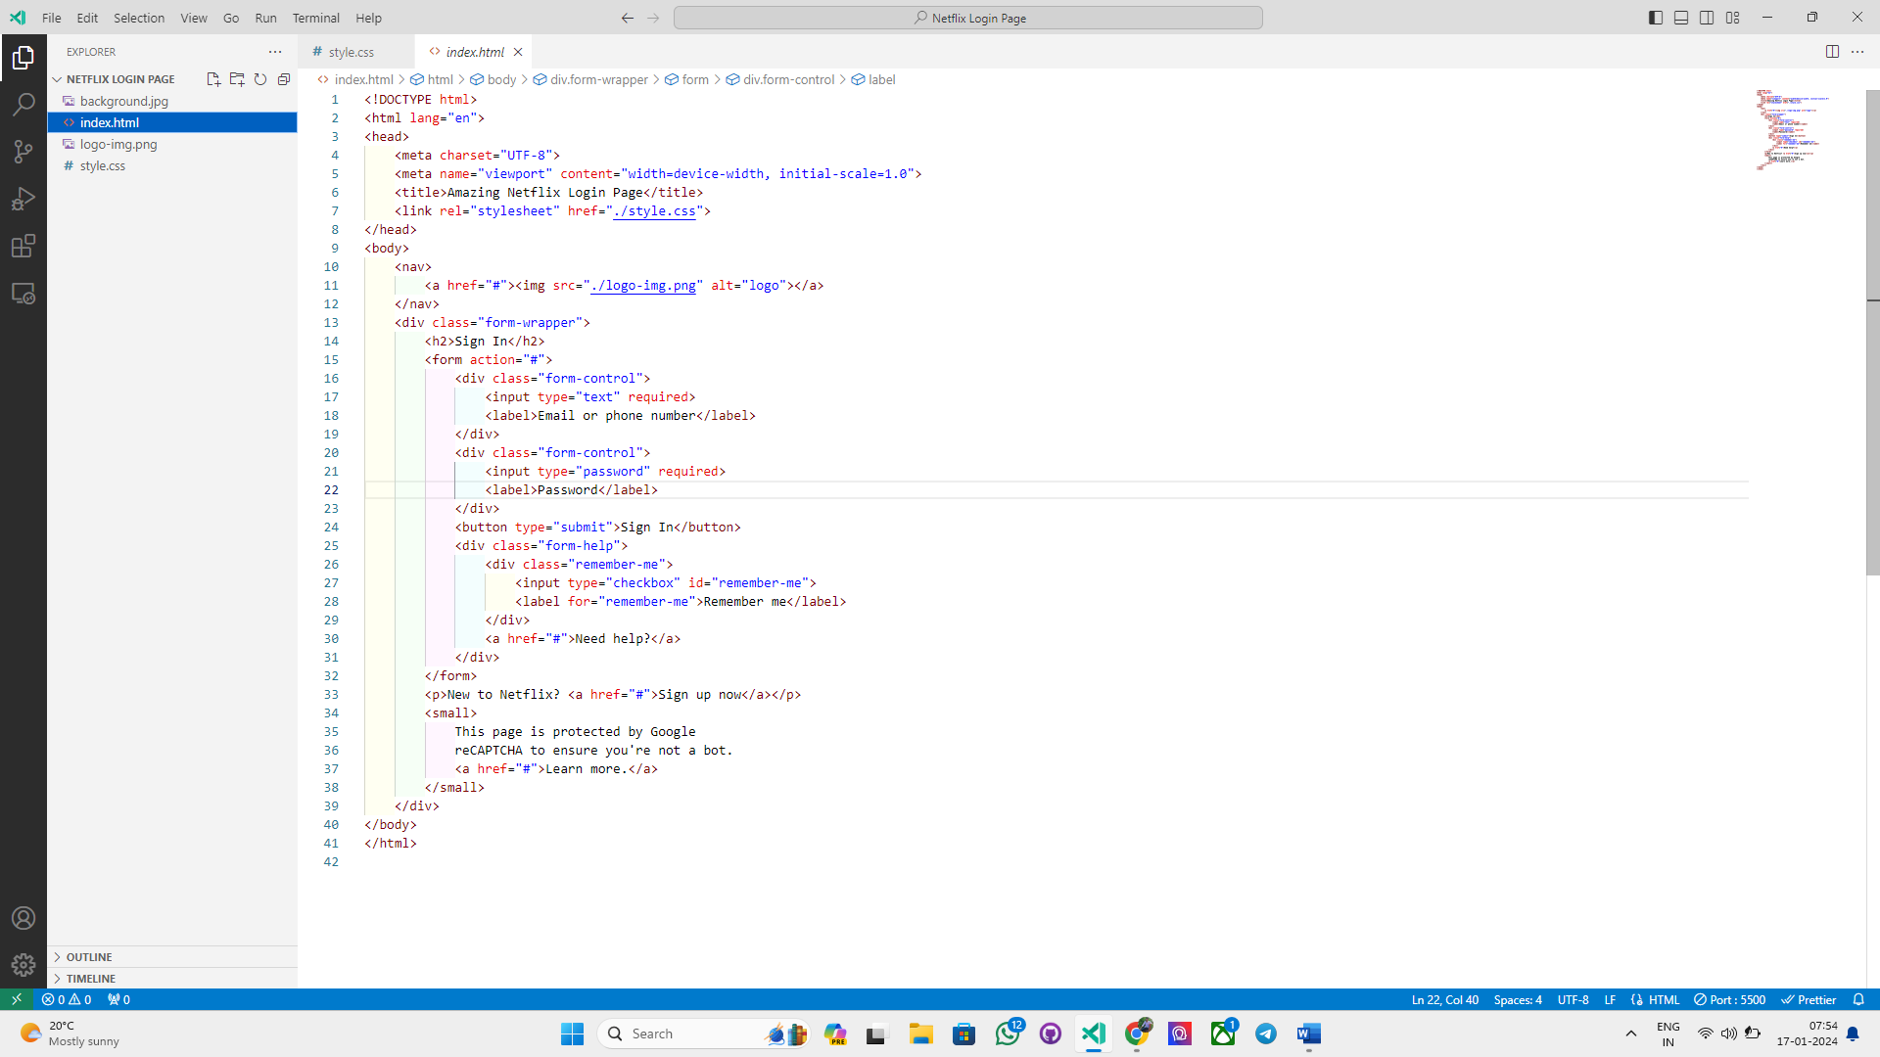

Furthermore, the implementation of semantic HTML tags and accessibility features underscores Netflix's commitment to inclusivity and user-centered design.

**CSS styling and layout**

**Visual Hierarchy**

The CSS styling on the Netflix login page leverages visual hierarchy to direct user attention to key areas, such as the login form, without overwhelming the interface.

**Responsive Design**

CSS media queries are employed to ensure a responsive layout that adapts seamlessly to various devices and screen sizes, enhancing the user experience across platforms.

**Brand Consistency**

Netflix's distinctive branding elements are thoughtfully incorporated into the CSS styling, maintaining brand consistency and reinforcing the platform's identity.

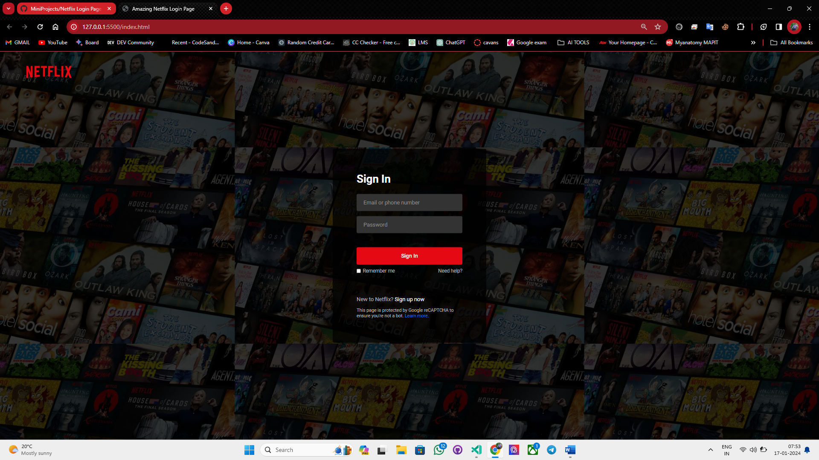

**Responsive design considerations**

|  |  |
| --- | --- |
| Device Compatibility | The Netflix login page is optimized to ensure compatibility across a wide range of devices, including smartphones, tablets, laptops, and smart TVs. |
| Fluid Layouts | Fluid grid layouts and flexible images are employed to create a responsive design that adapts to varying viewport sizes and orientations. |
| Performance Optimization | Efforts are made to minimize loading times and maintain optimal performance, regardless of the device used to access the login page. |

**User experience and accessibility**

**Accessibility Features**

The Netflix login page integrates accessibility features, such as aria-labels and proper contrast ratios, to ensure an inclusive and user-friendly experience for all individuals.

**Intuitive Navigation**

User experience is enhanced through intuitive navigation elements, ensuring a seamless transition from the login page to the main content.

**Personalization**

Advanced user recognition and personalization features contribute to a tailored login experience, aligning with Netflix's focus on individualized content delivery.

**Conclusion and recommendations**

The Netflix login page represents a commendable example of user-centered design, effectively balancing aesthetics, functionality and accessibility. Ongoing user testing and continued exploration of technological advertisements will ensure that the login page remains a seamless and enjoyable experience for Netflix users.